**Amazon EC2 Assignment CLOUD COMPUTING**

**Ali TAIMOOR DS211007 BSDS5A**

1. *EC2 INSTANCE CREATED SUCCESSFULLY*

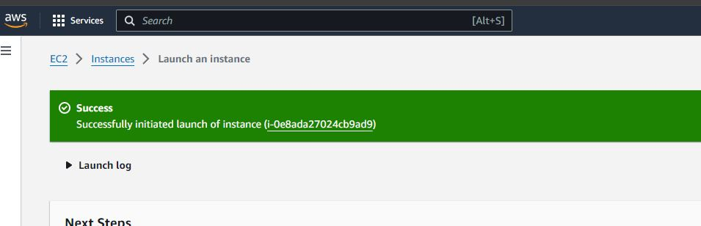

1. **Connect to INSTANCE**

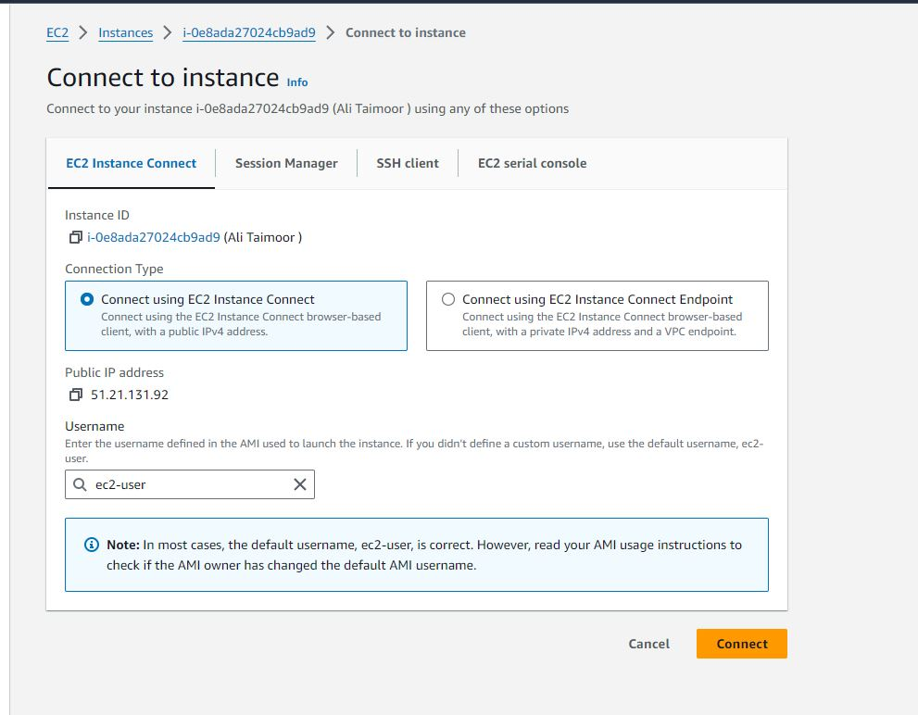

*3)INSTANCE LAUNCHED SUCCESSFULLY*

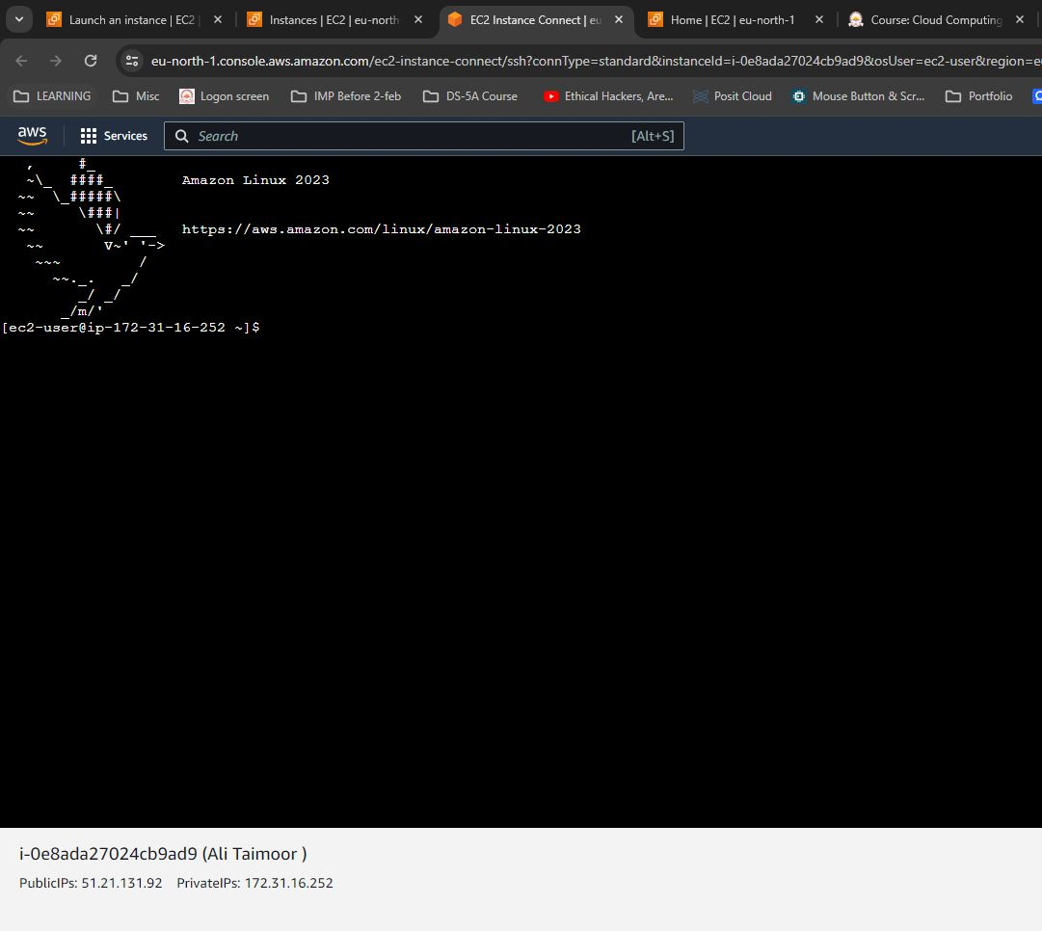

*4)S3 Created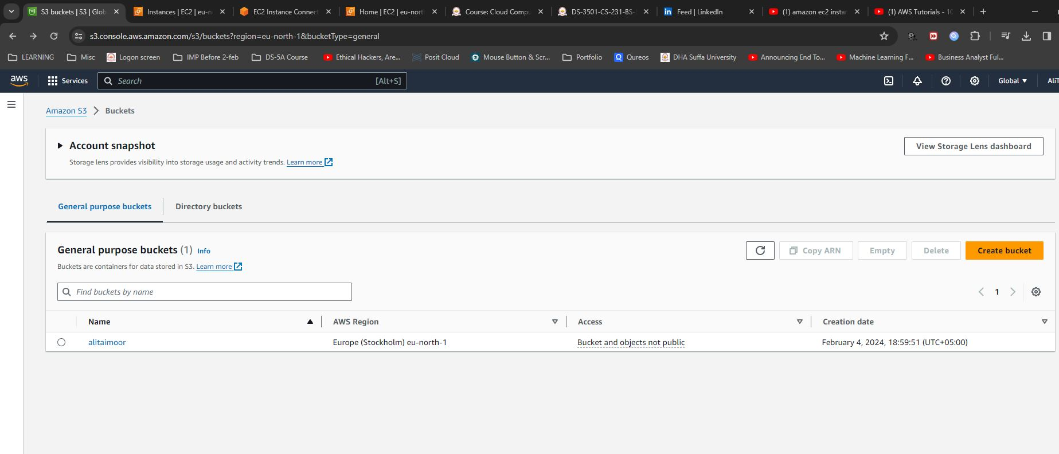*

*5)PIC UPLOADED IN S3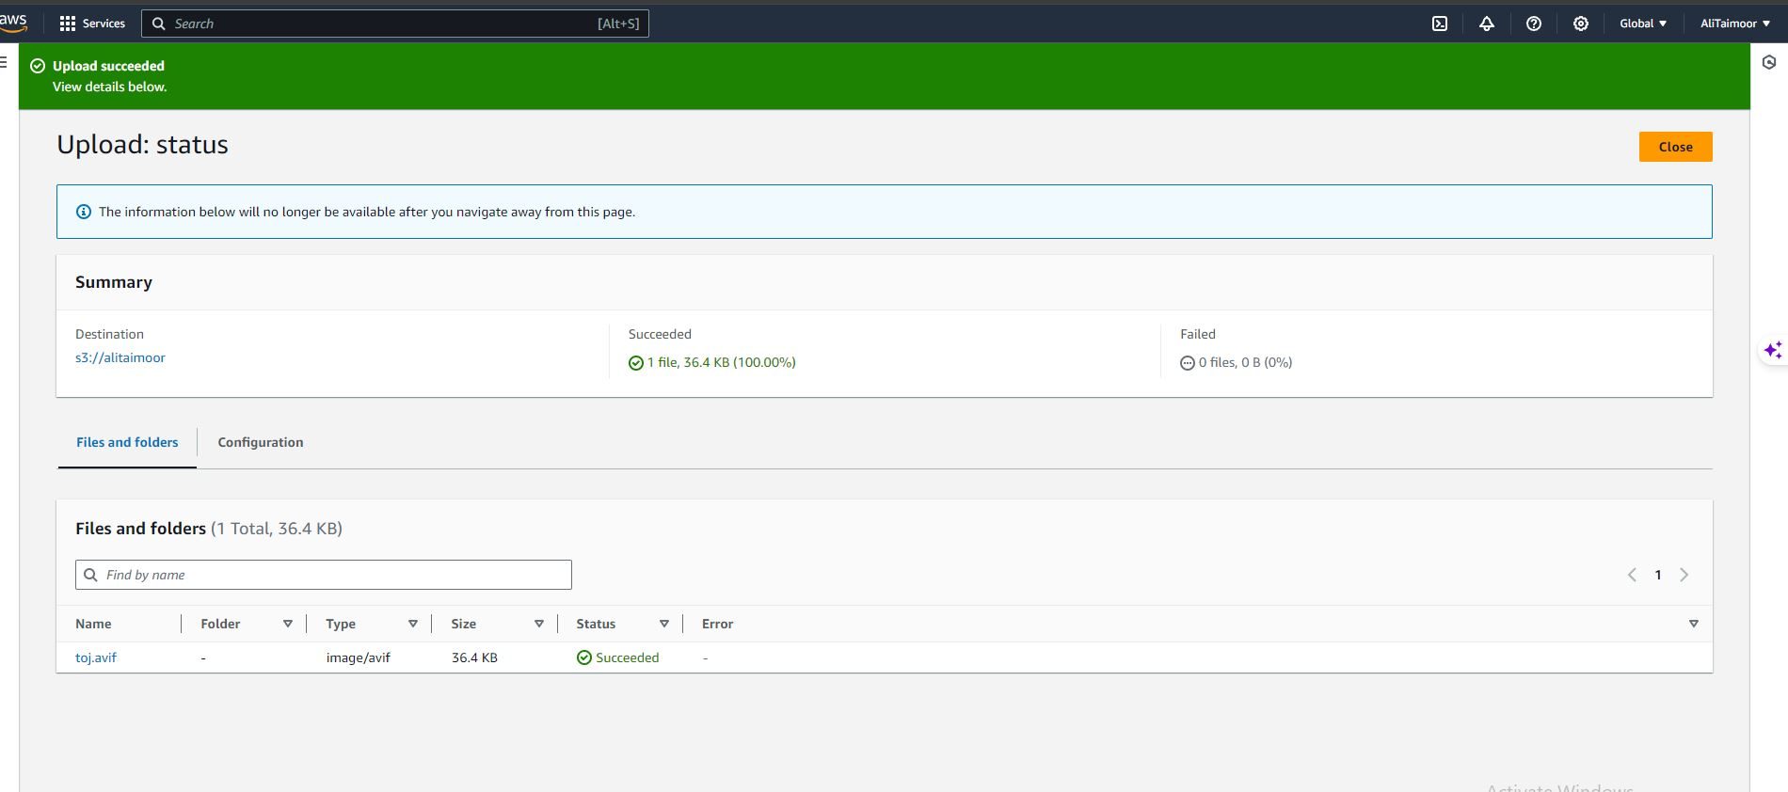*

*6) S3 CONNECTED TO EC2*

IMAGE toj.avif shown in console.

